**ACS545 Cryptography and Network Security**

**Firewall Evasion Lab: Bypassing Firewalls using VPN**

**Submission by- Surya Damerla (Suma)**

**2.1 Task 1: VM Setup**

1. Server

IP: 10.0.2.4

1. Client

IP: 10.0.2.6

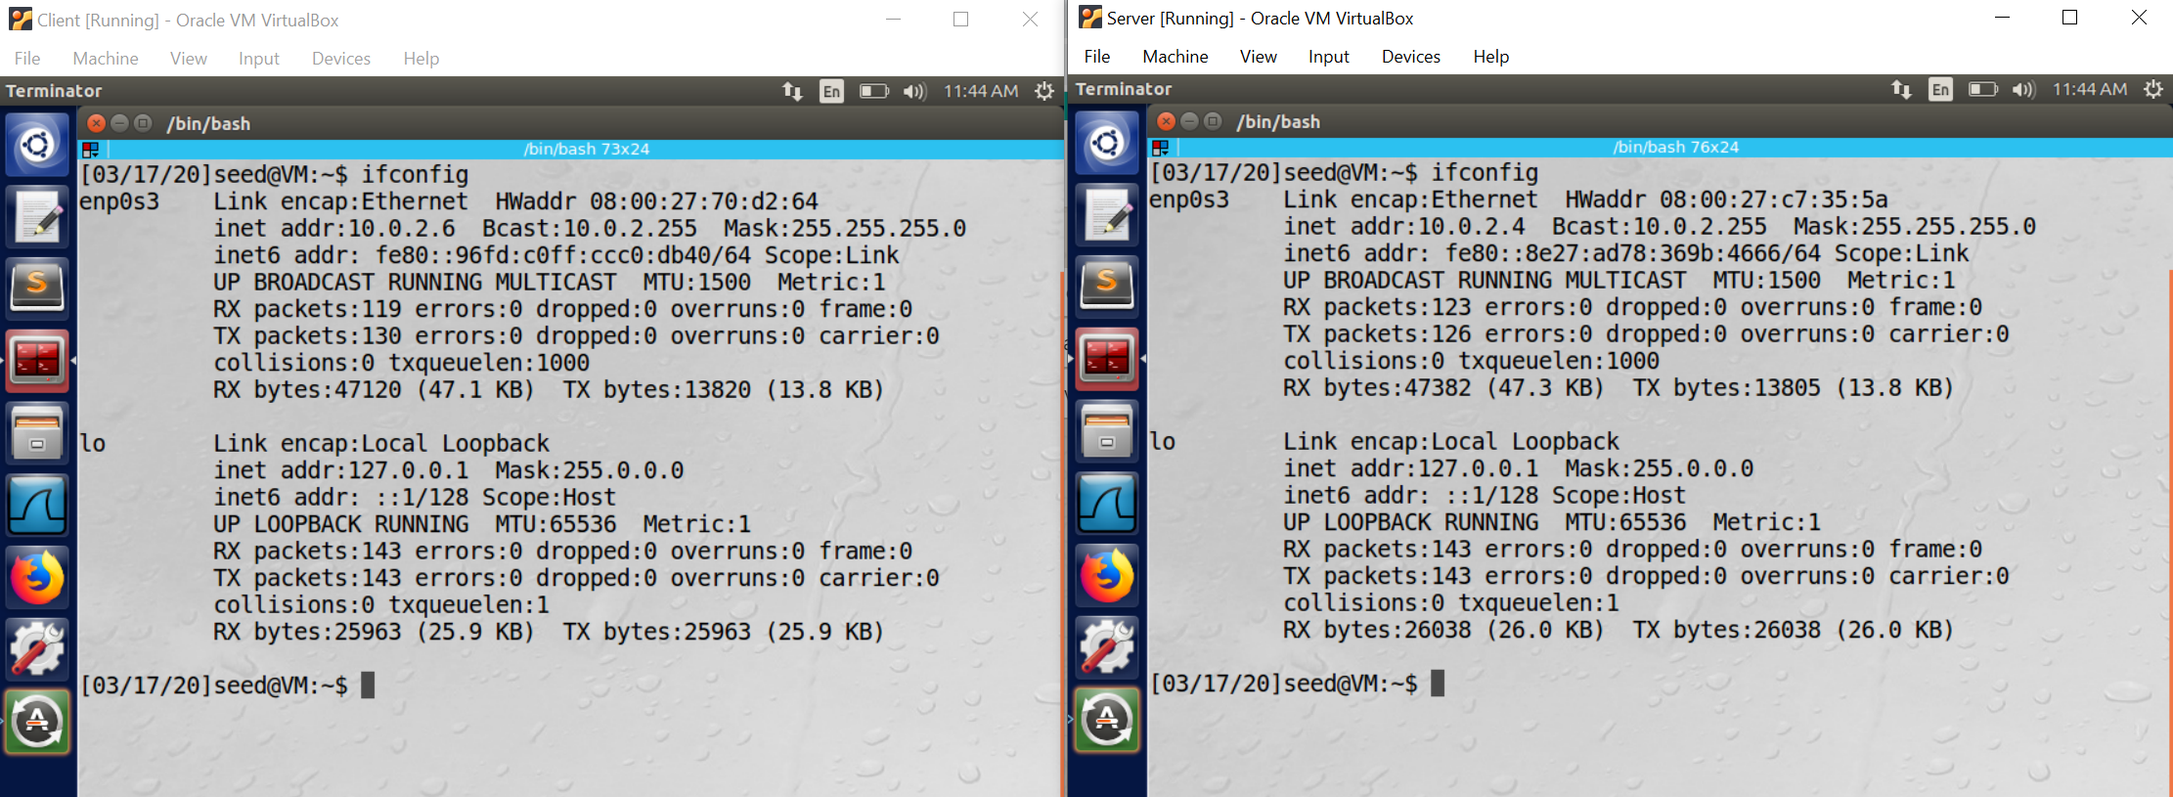

Figure 1.1

Both the client machine and server machine are in the same network.

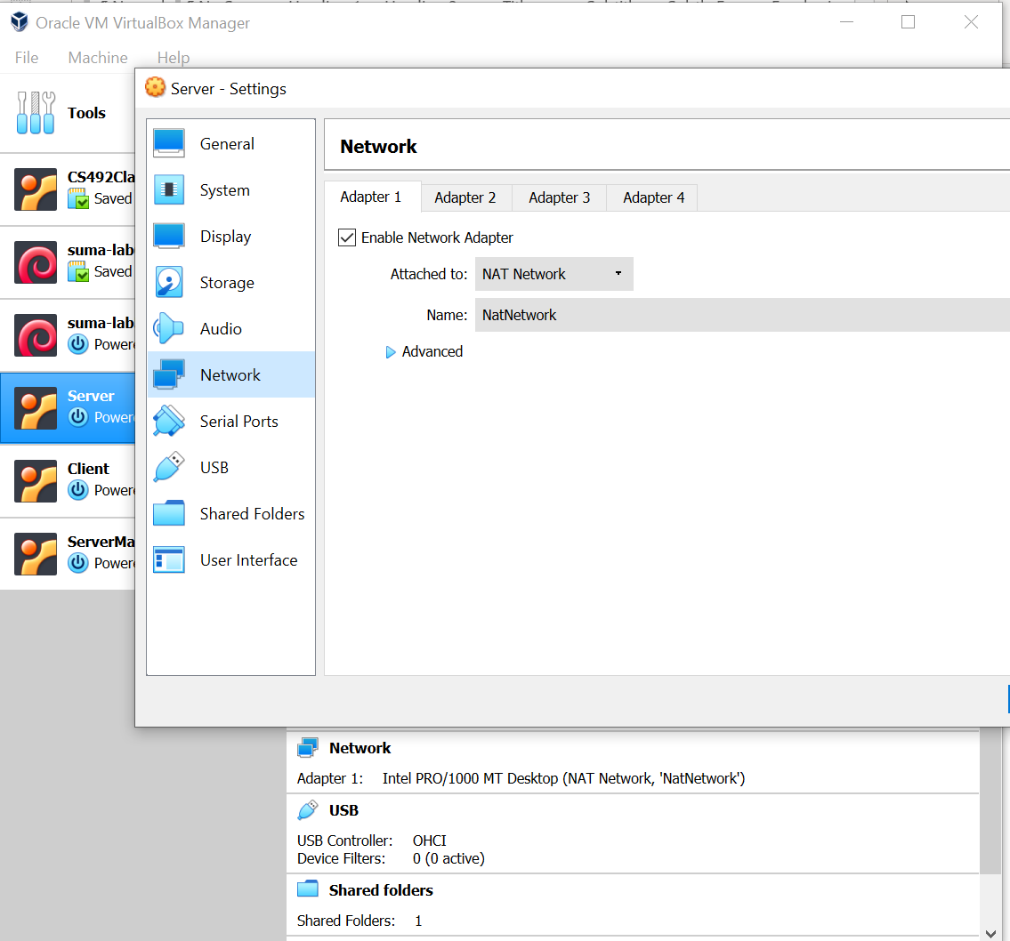

Figure 1.2. Server machine network configuration

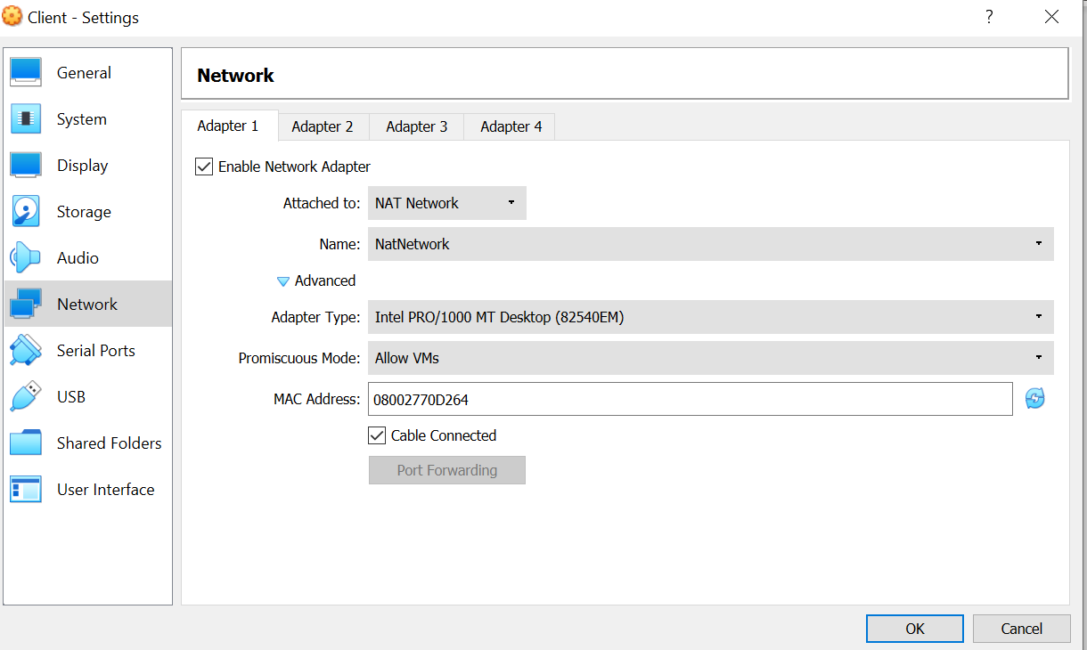

Figure 1.3. Client machine network configuration

**2.2 Task 2: Set up Firewall**

**Client machine:**

Facebook can be accessed by client before the firewall has been setup

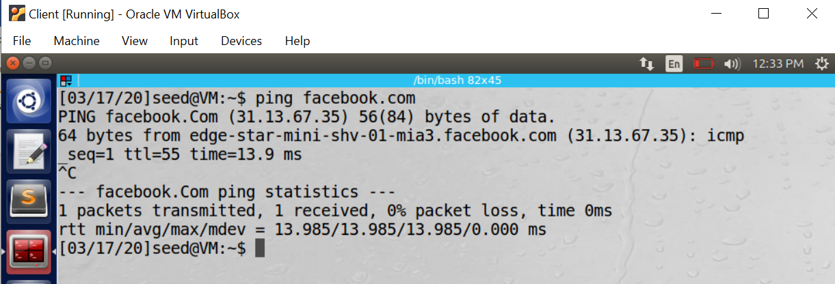

Figure 2. Ping to facebook in client machine

We can get the IP address of Facebook from “ping” command.

**Adding firewall in client machine to block Facebook access:**

**Rule:** sudo ufw deny out on enp0s3 to 31.13.67.0/24

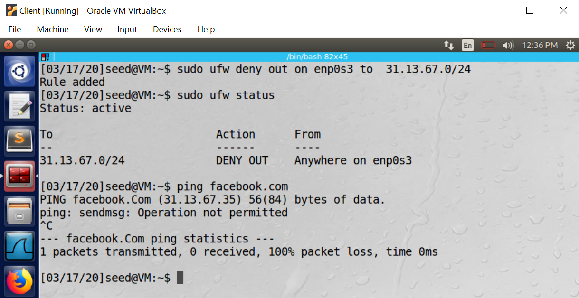

Figure 3. Setup of firewall to block facebook in client machine

If we try to ping facebook’s IP after adding the rule, the added firewall blocks it.

**2.3 Task 3: Bypassing Firewall using VPN**

**Step 1: Run VPN Server**

**Server machine:**

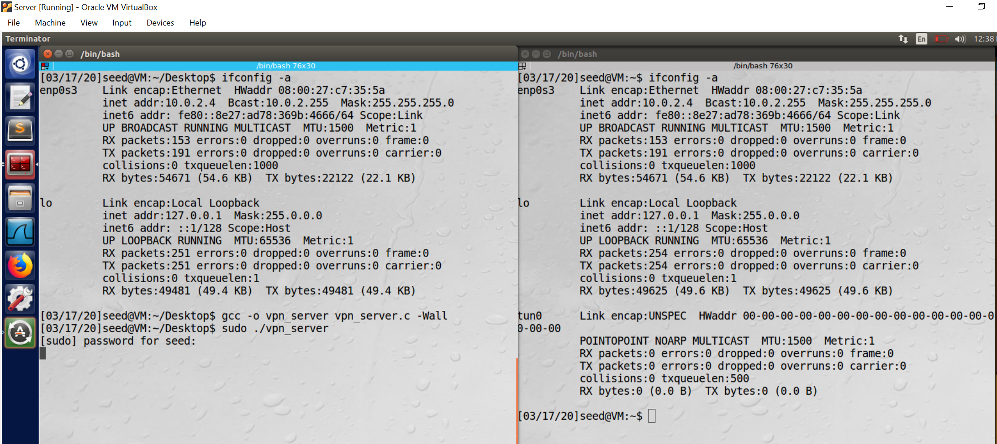

Figure 4. Creating tun interface in server machine

**Left terminal:**

Commands used:

1. *ifconfig -a*

2. To compile the code: *gcc -o vpn_server vpn_server.c -Wall*

3. To run the code: *sudo ./vpn_server*

**Right terminal:**

1. *ifconfig -a :* We can observe the *tun0* interface now.

The below command assigns an IP address to the tun0 inferface and then activates it.

**Command**: sudo ifconfig tun0 192.168.53.1/25 up

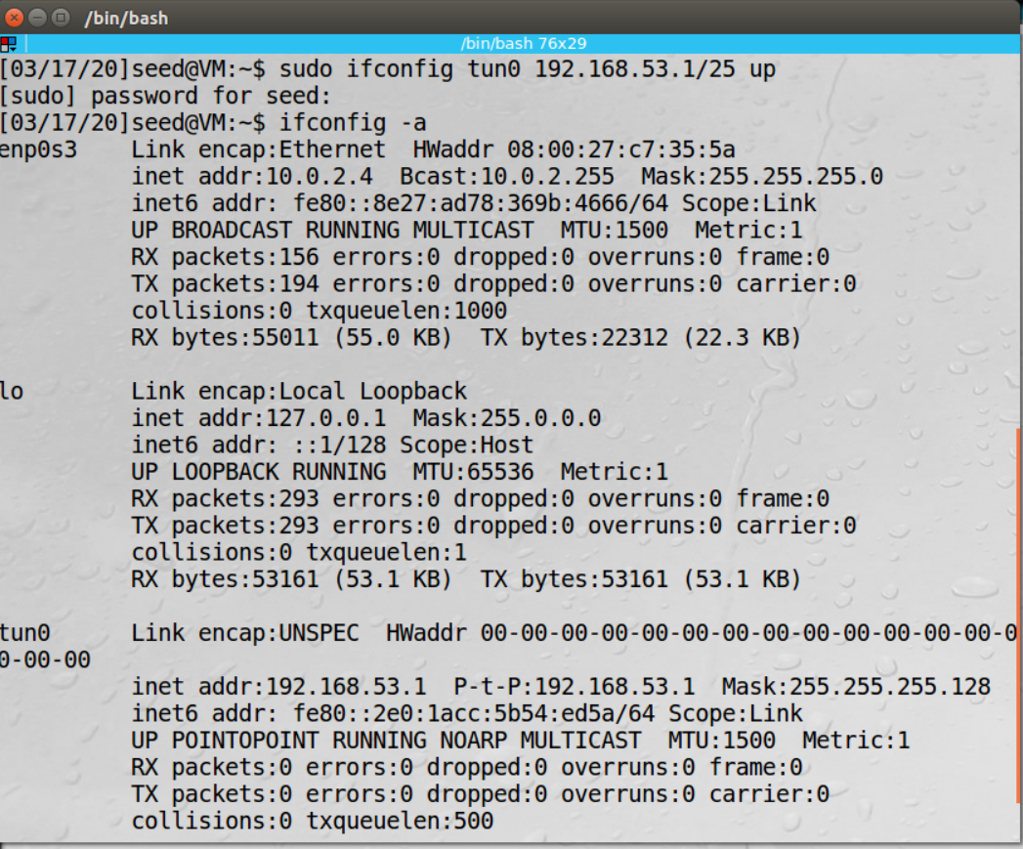

Figure 5.Activating tun0 interface in server machine

We need to enable the IP forwarding for a computer to behave like a gateway. IP forwarding can be enabled using the following command:

**Command:** *sudo sysctl net.ipv4.ip_forward=1*

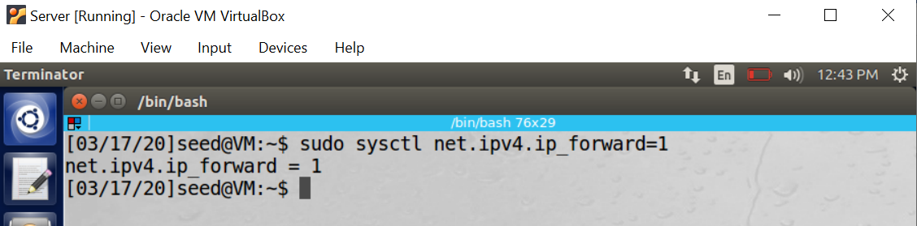

Figure 6. IP forwarding in server machine

**Step 2: Run VPN Client.**

**Client machine:**

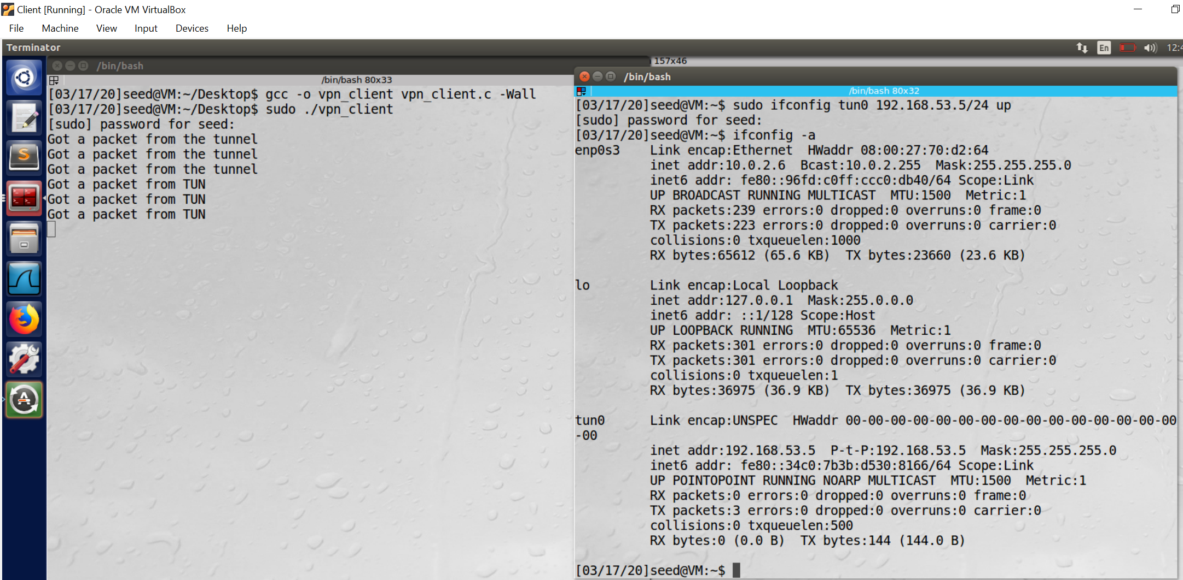

Figure 7. Setup tun0 interface in client machine

**Left terminal:**

Commands used:

1. *ifconfig -a*

2. To compile the code:

*gcc -o vpn_client vpn_client.c -Wall*

3. To run the code:

*sudo ./vpn_client*

**Observation:**

Running this code will create a network interface tun0 in the local machine.

**Right terminal:**

1. *sudo ifconfig tun0 192.168.53.5/24 up:*

Assigns the IP address to the tun0 interface and then activates it.

*2.* ifconfig -a :

Observe tun0 interface is now activated with IP 192.168.53.5

**Note:**

The code used for vpn_server.c and vpn_client.c is available as separate files in the folder.

Tunnel created:

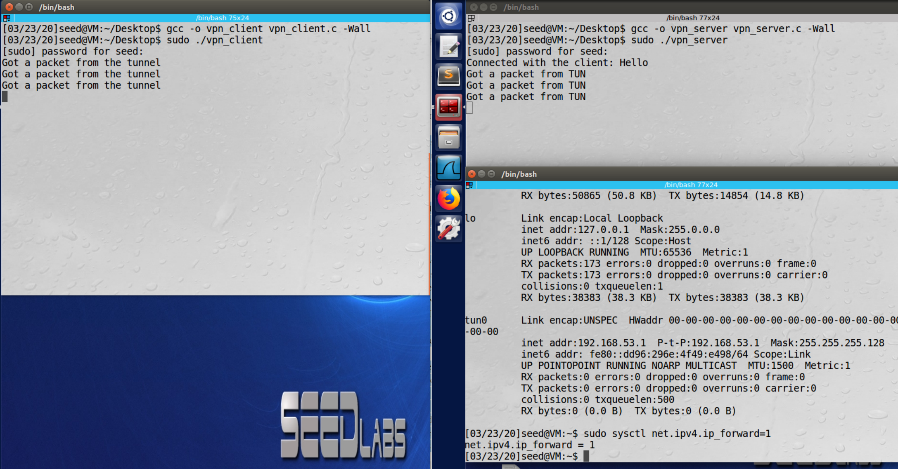



Figure 8. Tunnel between client and server machine

**Observation:** We can observe that a connection (tunnel) has been established between server machine and client machine. On the server machine(right terminal in the above figure), we can observe the message: “Connected with client: Hello”

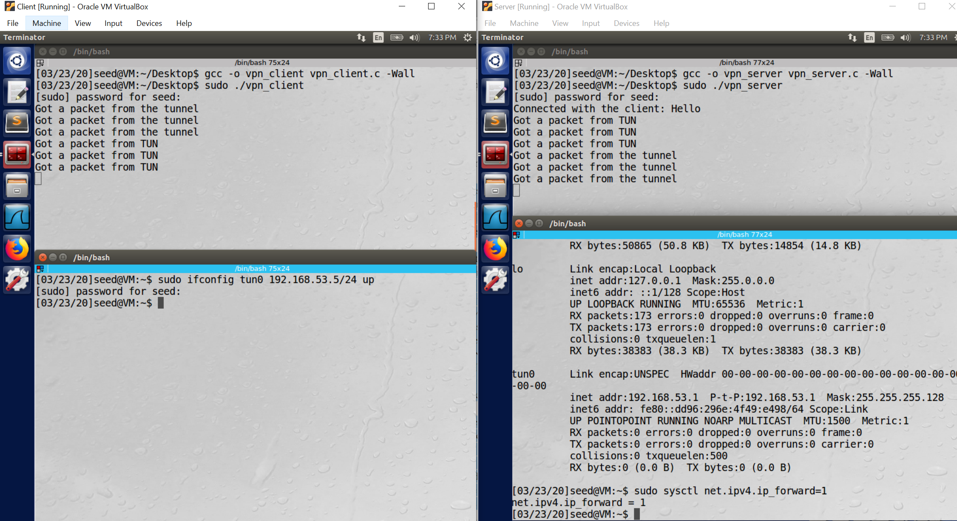

Figure 9. Tunnel between client and server machine after client tun0 is activated

**Observation:** After the client tunnel interface is activated, we can observe the messages got a packet from tunnel in the server machine and got a packet from TUN in the client machine

**Step 3: Set Up Routing on Client and Server VMs.**

**Command: sudo route add -net 31.13.67.0/24 tun0**

This ensures that all the packets from the IP address 31.13.67.0/24 (facebook’s IP) will be routed to tun0 interface

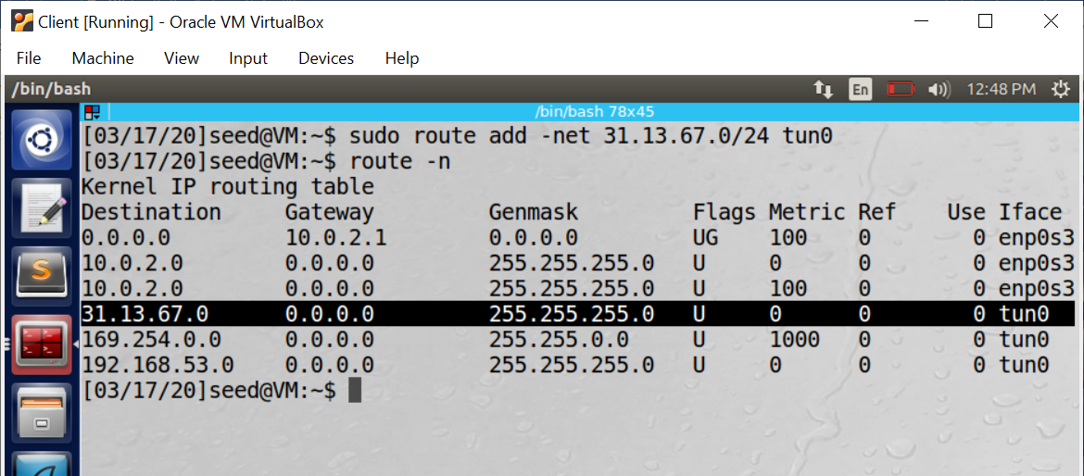

Figure 10. Setup routing in client machine

**Step 4: Set Up NAT on VPN Server**

* The return packet will reach the VPN Server’s NAT adapter ﬁrst (because the source IPs of all the outgoing packets from the Server VM are changed to the NAT’s external IP address (which is basically the host computer’s IP address in our setup).
* Usually, the NAT will replace the destination IP address with the IP address of the original packet (i.e. 192.168.53.5) and give it back to whoever owns the IP address. Since, this IP is of a virtual tun0 interface, NAT will not forward it to tun0 because it does not find a recipient ( MAC address)
* If NAT can be setup like a gateway, it can route the packets for 192.168.53.5 to the VPN Server, which will eventually deliver the packets through the tunnel to the VPN Client.
* However, we have not ﬁgured out how to conﬁgure the NAT as a gateway in VirtualBox, we did come up two work-around solutions:
* **ARP cache poisoning** : we make NAT to believe that the MAC address of 192.168.53.5 is the VPN server’s MAC address.
* Create another NAT on server VM so all packets coming out of the Server VM will have this VM’s IP address as their source IP.

The following commands can enable the NAT on the Server VM:

*1. sudo iptables -F*

*2. sudo iptables -t nat -F*

*3. sudo iptables -t nat -A POSTROUTING -j MASQUERADE -o enp0s3*

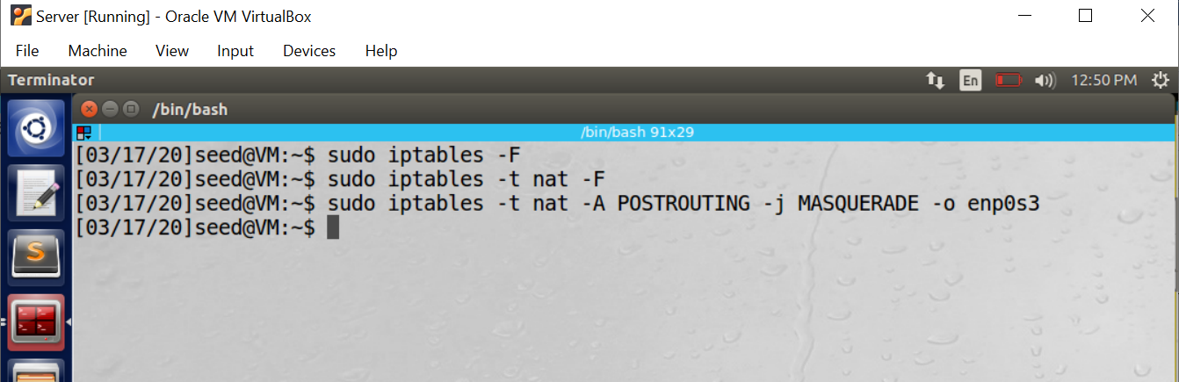

Figure 10. NAT setup on server

**Demonstration:**

Client machine can now access facebook.com through the tunnel established. We can try ping command.

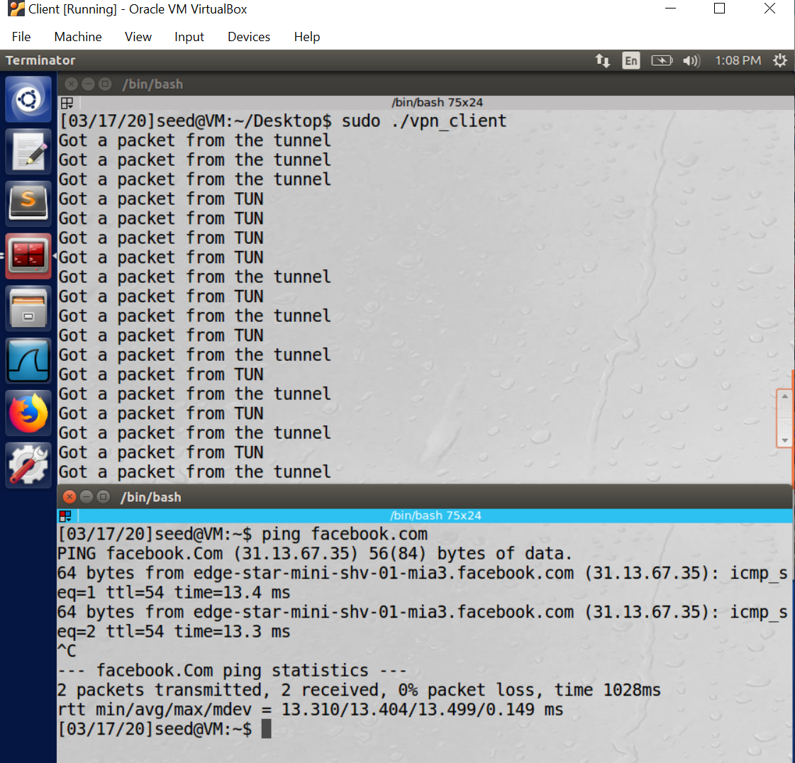

Figure 11. Successful ping to facebook from client bypassing firewall

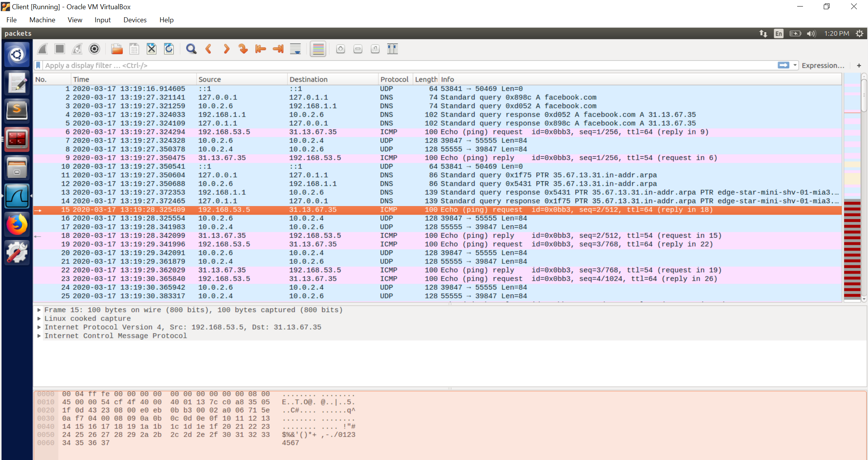

Figure 12. Wireshark capture

**Observation:**

We can observe that the ICMP request packet from tunnel interface (192.168.53.5) is created to facebook’s IP(31.14.67.35), the tunnel writes the packet to the UDP socket which sends the packet to server machine. (10.0.2.4). The ping reply is received back on tun0 interface.Hence, ping works bypassing firewall through the created tunnel.